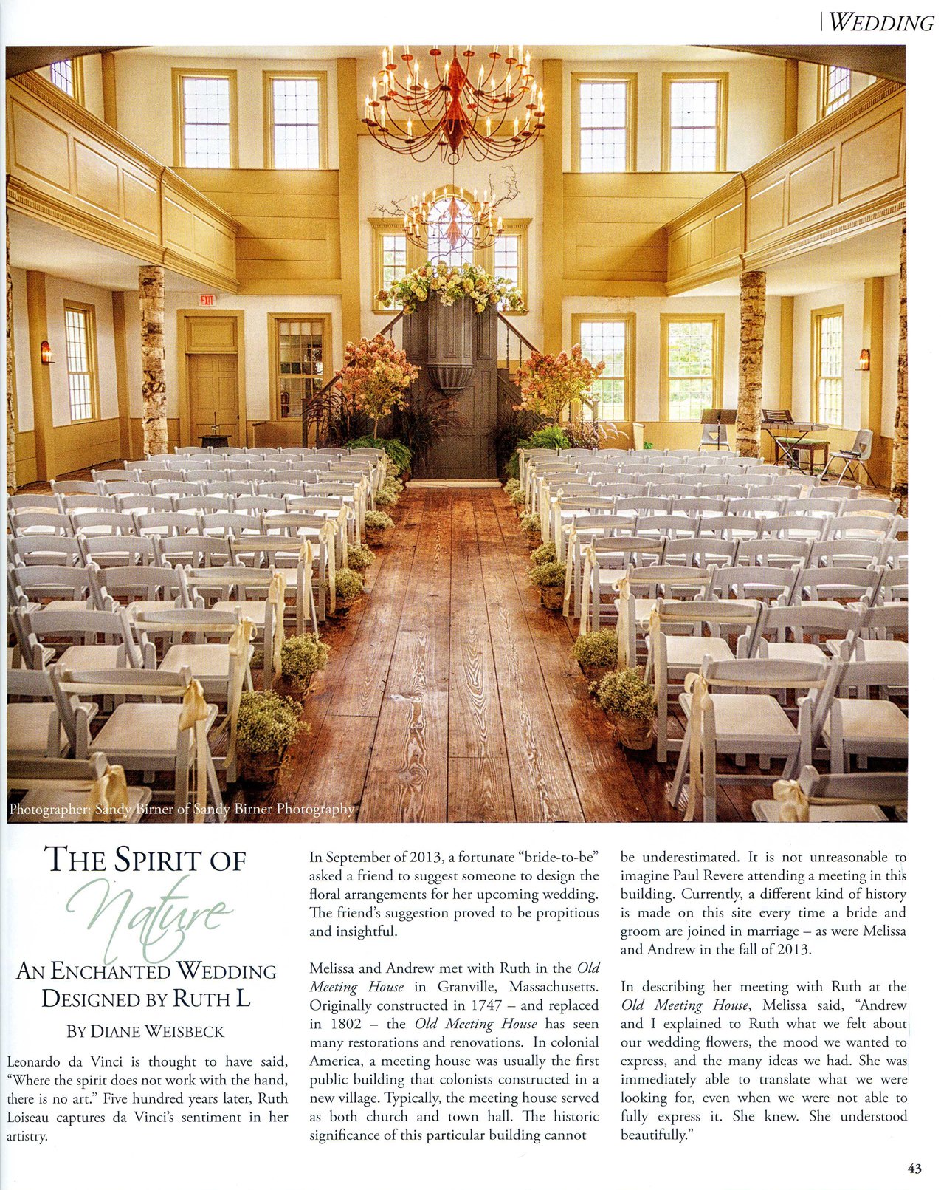

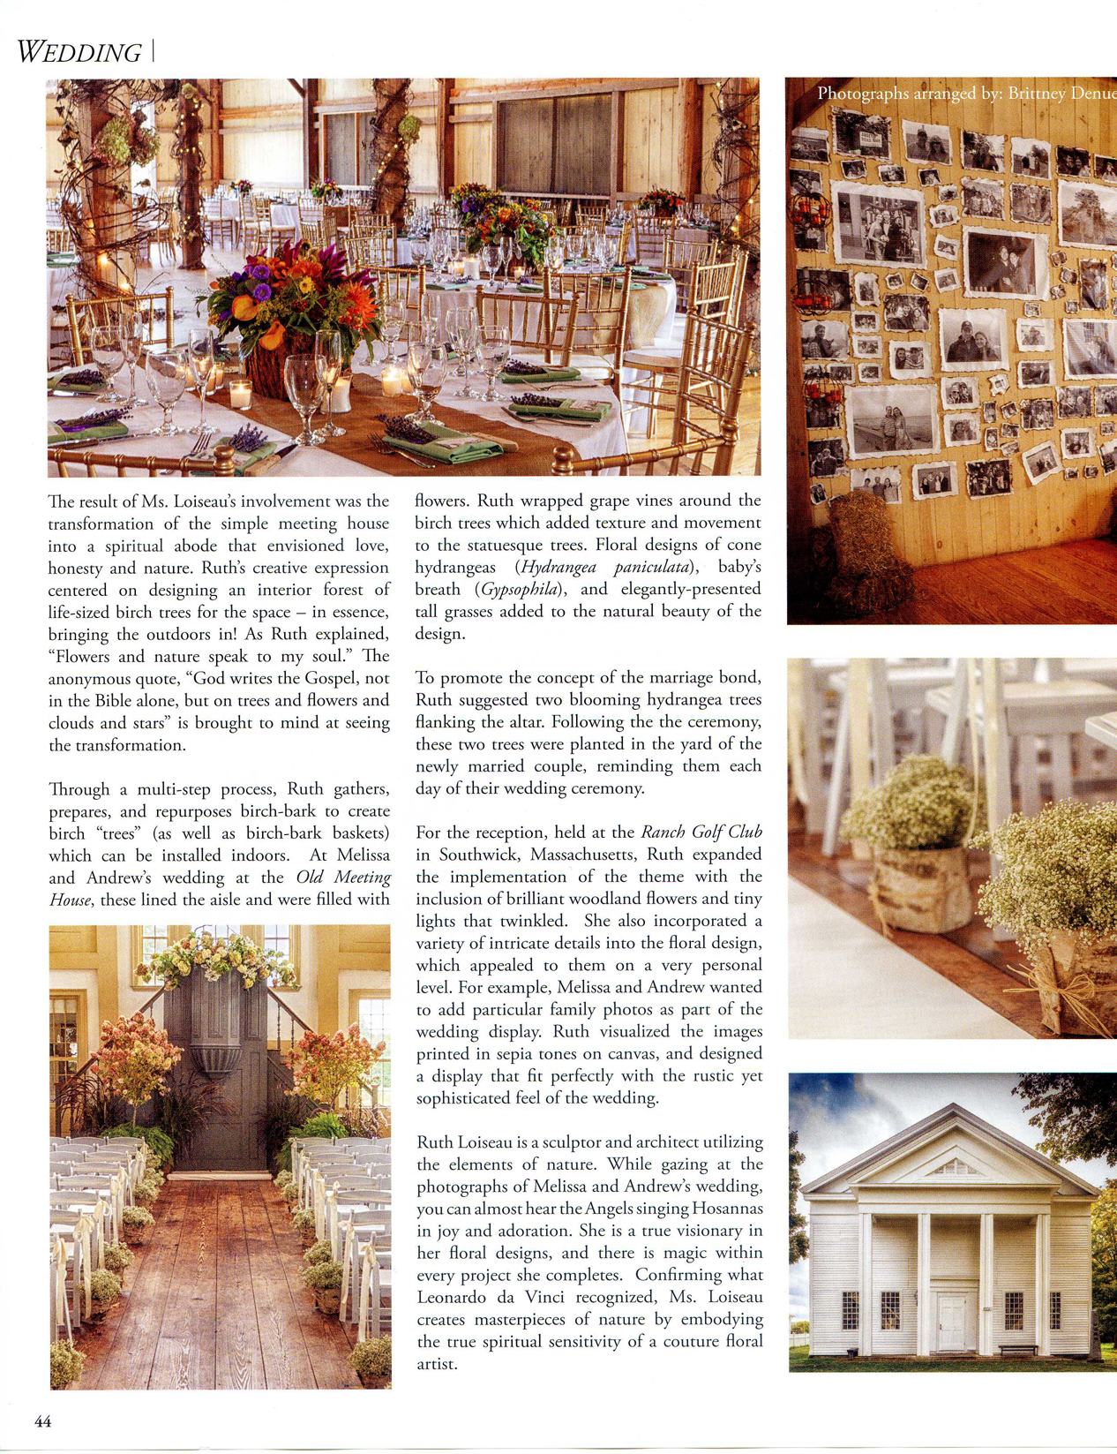
“The Spirit of Nature, an Enchanted Wedding Designed by Ruth L” by Diane Weisbeck for “Couture Flowers” print magazine. December, 2013.

